TOOLBD

TOOLSBD: Universal Client-Side Utility Suite
Version: 1.0
Status: Draft
Prepared by AL ESTIUK KHAN ABIR
Student, IUB.
TOOLSBD SYSTEM
Oct 19, 2026

Table of Contents
1. Introduction
1.1 Purpose
1.2 Document Conventions
1.3 Intended Audience and Reading Suggestions
1.4 Product Scope
1.5 References
2. Overall Description
2.1 Product Perspective
2.2 Product Functions
2.3 User Classes and Characteristics
2.4 Operating Environment
2.5 Design and Implementation Constraints
2.6 User Documentation
2.7 Assumptions and Dependencies
3. External Interface Requirements
3.1 User Interfaces
3.2 Hardware Interfaces
3.3 Software Interfaces
3.4 Communications Interfaces
4. Domain Model
5. System Features (Use Cases)
5.1 Use Case <Insert the specific use case name>
5.2 …
6. Other Nonfunctional Requirements
6.1 Performance Requirements
6.2 Safety Requirements
6.3 Security Requirements
6.4 Software Quality Attributes
7. Other Requirements

Revision History
Name | Date | Reason For Changes | Version | Date of Approval
Al Estiuk Khan Abir | 19/10/26 | Initial Baseline Specification for TOOLSBD | 1.0 | 19/10/26

Introduction

Purpose
This document specifies the software requirements for TOOLSBD (Version 1.0), a privacy-first, zero-server universal web application. The purpose of this SRS is to define the functional, non-functional, and interface requirements for the application, which operates entirely within client-side browser memory.

Document Conventions
- Font/Formatting: Bold text highlights UI elements and requirements identifiers.
- Tracking Changes: Additions and revisions are tracked in Section Revision History.
- Requirement Identifiers: System features and requirements follow standard code prefixes (e.g., FR-1 for Functional Requirements, NFR-1 for Non-Functional Requirements).

Intended Audience and Reading Suggestions

ID | Stakeholder | Description
S-1 | Customer | Checks alignment of privacy goals and functional specifications against project expectations.
S-2 | Development team | Provides technical architecture specifications, API requirements, and use case flows.
S-3 | QA team | Serves as the baseline for creating test plans and test scenarios.
S-4 | PM/BA | Used for resource planning, scope verification, and timeline estimation.
S-5 | User | Serves as the foundation for Terms of Service and Privacy Policy guarantees

Reading Sequence: Readers should begin with Section 1 and Section 2 for an overview, then proceed to Section 3 (Interfaces) and Section 5 (System Features / Use Cases).

Product Scope
TOOLSBD is a client-side Single Page Application (SPA) designed to perform everyday file conversions, optical code operations, and media processing directly within the web browser.
- Primary Scope: Provides local document processing (JPG/PNG to PDF compilation), media transcoding (MP4 to MP3 extraction), optical utilities (QR code generation, live camera/image QR scanning, 1D Barcode generation), AI media editing (background removal and watermark erasing), and an interactive assistant (Hermes Agent).

- Core Value: Zero cloud data uploads, ensuring data privacy, zero server dependency, and instant offline-capable execution.

References
- IEEE Std 830-1998, IEEE Recommended Practice for Software Requirements Specifications.
- TOOLSBD One-Page Project Proposal & Requirements Analysis Document.
- Web API Standards: HTML5 Canvas, Web Audio API, WebRTC MediaDevices, and WebAssembly (WASM) Specifications.

Overall Description

Product Perspective
TOOLSBD is a standalone, browser-based utility suite. Unlike traditional web converters that rely on backend cloud servers for file processing, TOOLSBD delegates all computational tasks to client-side Web APIs and WebAssembly libraries running directly inside the user's browser.
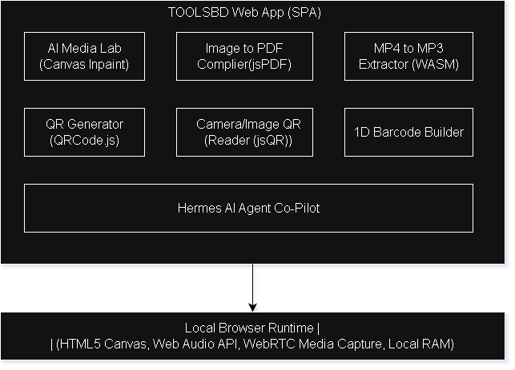
2.2Product Functions
- Document Compilation: Combine multiple JPG, PNG, and WEBP images into a formatted PDF document.

- Media Audio Extraction: Extract high-quality audio bitstreams from video clips (MP4, WEBM) to WAV/MP3 files locally.

- Optical Code Suite:
- Generate custom QR codes from URLs or plain text.
- Scan and decode QR codes live from uploaded image files or webcam feeds.
- Generate standard 1D industrial and commercial barcodes (CODE128, EAN-13).

- AI Media Lab: Perform image background isolation and text/watermark erasing using client-side canvas masking.

- Hermes Agent Interaction: Provide interactive guidance, route workflow tasks, and analyze uploaded media parameters dynamically

2.3User Classes and Characteristics

ID | User classes | Description
U-1 | General Web User | Performs basic conversion tasks (e.g., photo to PDF, generating QR codes). Requires an intuitive, no-code graphical interface.
U-2 | Privacy-Conscious User | Processes confidential files, legal documents, or private photos. Demands strict guarantees that no data is transmitted to external servers.
U-3 | Student / Office Worker | Batch converts documents, extracts meeting audio, or generates barcodes for product/inventory management.

2.4Operating Environment
- Hardware Platform: Any standard computer or mobile device with a modern dual-core CPU and a minimum of 2GB available RAM.
- Operating System: Platform independent (Windows, macOS, Linux, Android, iOS).
- Client Software: Google Chrome, Mozilla Firefox, Microsoft Edge, Apple Safari.
- Network Requirement: Internet connection required only for initial loading of CDN assets; fully functional offline thereafter.

2.5Design and Implementation Constraints
The development and deployment of TOOLSBD are bound by several design and technical constraints that limit implementation choices for developers. These constraints ensure the application achieves its core vision: a 100% client-side, zero-server, privacy-first universal utility suite

1. Specific Technologies, Tools, and Databases to be Used
- Frontend Languages: Must be implemented strictly using standard, non-compiled client-side technologies: HTML5, CSS3 (styled via Tailwind CSS CDN), and ECMAScript 2022+ vanilla JavaScript.
- Client-Side Libraries: Restricted to lightweight, browser-executable JavaScript open-source libraries:
  - jsPDF (v2.5.1) for client-side raster-to-vector PDF compilation.
  - jsQR (v1.4.0) for array pixel decoding of QR codes.
  - JsBarcode (v3.11.5) for SVG 1D barcode generation.
- Database Constraint: No centralized server database (e.g., PostgreSQL, MongoDB) or cloud store shall be used. Application persistence and transient state are restricted to browser-native localStorage and IndexedDB storage engines.

2. Hardware Limitations (Timing and Memory Requirements)
- Client Memory Boundaries: All processing—including canvas pixel buffers, image arrays, and audio bitstream extractions—must execute entirely within the browser's allocated memory space (typically 1.5 GB to 2.0 GB RAM per tab).
- Buffer Management: Developers must explicitly implement garbage collection practices (e.g., invoking URL.revokeObjectURL() and clearing canvas context buffers) to prevent browser tab crashes during high-resolution processing.
- Timing & Responsiveness: Interactive utilities (QR and Barcode generation) must render in under 100 milliseconds. Batch file compilations must execute within 3 seconds on dual-core hardware without freezing the browser's UI thread.

3. Binding Agreements or Development Standards
- IEEE Std 830-1998 Alignment: Requirements, use case specifications, and system interfaces must adhere strictly to standard Software Requirements Specification structure.
- W3C Web API Standards: Media capturing and canvas manipulation must strictly comply with official W3C specifications for WebRTC MediaDevices, HTML5 Canvas API, and Web Audio API.

4. Restrictions Imposed by Business Rules
- Zero Cloud Data Upload Guarantee: The fundamental core business rule mandates that user files (documents, video clips, optical scans, edited images) must never be transmitted over a network to external cloud servers.
- Open & Free Access: All tools must function fully without user registration, authentication gates, daily conversion quotas, or paywalled features.

5. Interfaces to Other Applications
- No Direct REST Backend Services: The application cannot rely on cloud conversion endpoints (such as iLovePDF REST or Canva APIs) that require server secret keys or backend proxies.
- Webcam Interface: Real-time QR scanning depends on user-granted permissions via navigator.mediaDevices.getUserMedia().

6. Standard Data Exchange Formats
- Media & File Blobs: Internal file exchange and DOM preview links must utilize client-side data: URI streams and local blob: binary object schemes.
- Structured Payload & Codes: Barcodes and QR payload structures follow standard string encodings (CODE128, EAN-13, vCard format, and standard UTF-8 URL strings).

7. Design Conventions or Programming Standards
- Maintainability & Modular Architecture: JavaScript functions inside app.js must adhere to modular function separation (e.g., separating UI tab routing, canvas pixel manipulation, and PDF compilation into discrete handlers).
- UI Design System: The interface must maintain a modern, responsive Dark Mode Glassmorphism layout using utility-first Tailwind CSS classes.

8. Language Requirements
- Primary System Language: English (UTF-8 character encoding) for all UI button labels, instructions, error messages, and assistant prompt responses.

9. Communications Protocols
- Asset Loading Protocol: HTTPS protocol is strictly required for initial loading of web assets and CDN libraries to ensure WebRTC camera permissions are permitted by browser security policies.
- Offline Processing: Once static assets are cached, all utility features must function without active internet connectivity.

10. Security Considerations
- Volatile Memory Storage: Processed outputs must remain in temporary client memory and be discarded upon browser tab close or refresh.
- Sandboxed Execution: All processing runs inside the browser sandbox, preventing unauthorized access to the client’s local filesystem beyond user-selected dropzones.

2.6User Documentation
- Interactive Tooltips: Contextual help integrated directly into the workspace tabs.
- Hermes AI Co-Pilot: An embedded assistant providing real-time instructions and usage guidance.

2.7Assumptions and Dependencies
Assumptions: Users operate devices with sufficient client-side RAM to process their uploaded file sizes.
Dependencies: Relies on lightweight, open-source client-side JavaScript libraries loaded via CDN: jsPDF, jsQR, QRCode.js, and JsBarcode.

External Interface Requirements

User Interfaces
- Theme & Layout: Dark-mode responsive design built with Tailwind CSS, featuring a sticky top navigation bar and dynamic glassmorphism panels.
- Module Views:
- AI Media Lab View: Dual drag-and-drop file upload zones, side-by-side Canvas viewports, and action triggers.
- Image to PDF View: Multi-image grid container with preview thumbnails and page reordering.
- MP4 to MP3 View: Video file drag dropzone with instant Web Audio decoding status and download links.
- QR & Barcode Suite View: Multi-column layout containing input text controls, real-time preview canvases, and an image scan uploader.
- Hermes AI Assistant: Slide-out side drawer with a persistent chat interface.

- Hardware Interfaces
- Camera Input Device: WebRTC (navigator.mediaDevices.getUserMedia) interface for capturing optical camera feeds during live QR code scanning.
- Display Output: Standard monitor/mobile screen rendering at minimum $1024×768$ (desktop) or $360×640$ (mobile) resolutions.

Software Interfaces
- HTML5 Canvas API: Used for local image rendering, pixel buffer manipulation, and threshold masking.
- Web Audio API: Used for local decoding and stripping of audio bitstreams from imported video files.
- jsPDF Library (v2.5.1): Interfaces with client-side memory to compile raster graphics into vector PDF files.
- jsQR Library (v1.4.0): Parses raw image pixel arrays to locate and decode QR code matrix data.
- JsBarcode Library (v3.11.5): Renders 1D barcodes directly onto DOM SVG elements.

Communications Interfaces

- Protocol: HTTPS for initial delivery of static HTML/JS web assets.
- Data Transfer Security: Zero outbound data transmission during file processing. All user files remain strictly within local memory (blob: and data: URI schemes).

Domain Model
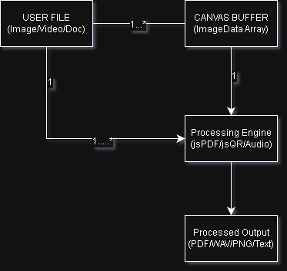

System Features (Use Cases)

5.1 Use Case 1: Convert Images to Multi-Page PDF
- Brief Description: The user uploads multiple images (JPG, PNG, WEBP), and the system compiles them into a downloadable PDF document locally in browser memory.
- Business Trigger: User requires a single structured PDF file created from multiple separate photo files.
- Preconditions: The application is open in a supported web browser.

Basic Flow:
Line | System Actor Action | System Response
1 | User selects the "Image to PDF" module from the navigation bar. | The system displays the multi-file drag-and-drop zone.
2 | User selects and uploads multiple image files. | The system reads the image buffers locally and renders page preview thumbnails.
3 | User clicks the "Compile & Download PDF" button. | The system initializes jsPDF, embeds each image on a new PDF page, generates a blob download link, and triggers a file save.
- Post Condition: A multi-page PDF document is saved to the user's local file storage.

Alternate Flow (AF-1): Invalid File Upload
- If at line 2 an unsupported file format (e.g., .exe or .txt) is uploaded:
  - System alerts the user with an error message: "Invalid format. Please upload JPG, PNG, or WEBP images."
  - The use case restarts at line 1.

5.2 Use Case 2: Extract Audio from MP4 Video
- Brief Description: The user imports a video file, and the system extracts its embedded audio track into a standalone downloadable audio file.
- Business Trigger: User wants to isolate speech or music from a video clip without uploading the file to a cloud service.
- Preconditions: A valid video file (MP4, WEBM) is accessible on the user's device.

Basic Flow:
Line | System Actor Action | System Response
1 | User navigates to the "MP4 to MP3" tab. | System displays the video dropzone.
2 | User drops a video file into the dropzone. | System decodes the video bitstream using the Web Audio API.
3 | Processing completes. | System displays the extracted filename and presents a "Save Audio" download button.
4 | User clicks "Save Audio". | System downloads the local audio file to the user's device.
- Post Condition: Audio file extracted and saved locally.

5.3 Use Case 3: Generate and Scan Optical Codes (QR & Barcode)
- Brief Description: User generates custom QR codes and 1D barcodes or uploads a QR code image to decode its text/URL payload.
- Business Trigger: User needs to create inventory barcodes, format QR codes, or read a QR code from a file.
- Preconditions: Browser loaded with jsQR, QRCode.js, and JsBarcode libraries.

Basic Flow:
Line | System Actor Action | System Response
1 | User selects the "QR & Barcode" tab. | System renders the three-column optical code workstation.
2 | User inputs text into the "QR Generator" input field. | System updates and renders the QR code canvas in real time.
3 | User inputs text into the "Barcode Generator" field. | System updates and renders the 1D CODE128 SVG barcode in real time.
4 | User uploads an image containing a QR code into the Scanner dropzone. | System extracts the pixel data using jsQR and displays the decoded text payload.
- Post Condition: Codes generated on screen or QR content successfully decoded.

5.4 Use Case 4: Image Background Isolation & Watermark Removal
- Brief Description: User uploads an image to isolate background elements or erase watermarks directly on an HTML5 canvas.
- Business Trigger: User needs to remove an unwanted photo background or text overlay locally.
- Preconditions: Image file is loaded into active canvas memory.

Basic Flow:
Line | System Actor Action | System Response
1 | User opens the "AI Media Lab" tab. | System displays the file input and canvas viewport.
2 | User uploads an image file. | System renders the image onto the working canvas.
3 | User clicks "Remove Background" or "Erase Watermark". | System applies client-side pixel buffer transformations and re-renders the canvas.
4 | User clicks "Download Processed Image". | System exports and downloads the resulting image as a transparent PNG.
- Post Condition: Edited image exported successfully.

5.5 Use Case 5: Hermes AI Agent Interaction
- Brief Description: User opens the Hermes assistant drawer to request help, format recommendations, or automated workflow navigation.
- Business Trigger: User requires assistance operating the utility suite.
- Preconditions: Hermes Agent drawer component is initialized.

Basic Flow:
Line | System Actor Action | System Response
1 | User clicks the "Hermes AI" button in the header. | System slides open the Hermes assistant drawer.
2 | User types a natural language query (e.g., "How do I make a PDF?") and hits Enter. | System parses the query keywords and context.
3 | System processes the intent. | System returns a contextual answer and guides the user to the appropriate module tab.

- Post Condition: User receives guidance and navigation assistance.

Other Nonfunctional Requirements

Performance Requirements
- Processing Latency: QR code and Barcode rendering must execute within 100 milliseconds of user input.
- Conversion Speed: JPG to PDF compilation for up to 10 images must complete within 3 seconds on standard client hardware.
- Client Memory Footprint: System baseline memory usage must remain under 150MB, expanding dynamically based on user file sizes without exceeding 1GB.

Safety Requirements
- Memory Protection: The application must clear unused canvas buffers and image arrays upon module switching to prevent browser tab memory exhaustion or freeze crashes.

Security Requirements
- Zero Data Transmission (100% Client-Side): User files, processed outputs, and decoded optical payloads must never be transmitted over a network to external backend servers.
- Local Storage Isolation: Processed files must reside strictly in temporary volatile browser memory unless explicitly downloaded by the user.

Software Quality Attributes
- Usability: Interface must be fully responsive across desktop, tablet, and mobile displays.
- Availability: Operates 100% offline once the web application assets are cached by the browser.
- Portability: Fully functional across modern versions of Chrome, Firefox, Safari, Edge, and Opera without requiring browser plugins or native software installations.

Other Requirements
- Internationalization: Interface strings and error displays must support standard Unicode (UTF-8) characters.
- Legal Compliance: Complies with strict data privacy frameworks (e.g., GDPR, CCPA) by design, as zero personally identifiable information (PII) or user data is collected, stored, or transmitted.

Appendix A: Glossary

Term | Description
Project | Modification of the existent Reputation.ca website
SPA | Single Page Application: A web application that fits on a single web page, updating content dynamically without full page reloads.
Canvas API | An HTML5 API used to draw graphics and manipulate image pixel buffers via JavaScript.
Web Audio API | A high-level Web API for processing and synthesizing audio operations inside the browser.
WA4SM | WebAssembly: A binary instruction format for executing high-performance code inside modern web browsers.
Hermes Agent | The embedded context-aware AI assistant integrated into the TOOLSBD interface.

Appendix B: Analysis Models
This appendix contains technical structural, data flow, and state transition models representing the internal behavior and architecture of TOOLSBD.
B.1 Data Flow Diagram (Level 1 DFD)
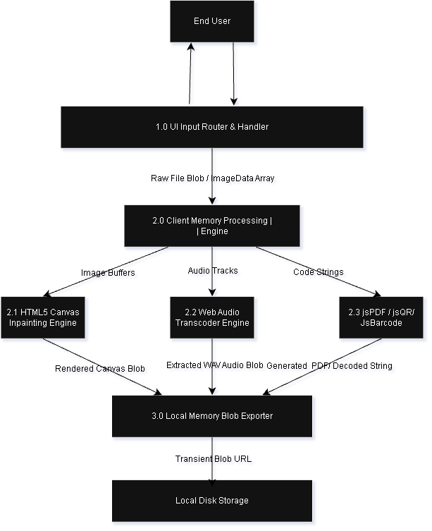

B.2 Hermes AI Co-Pilot State Machine Diagram

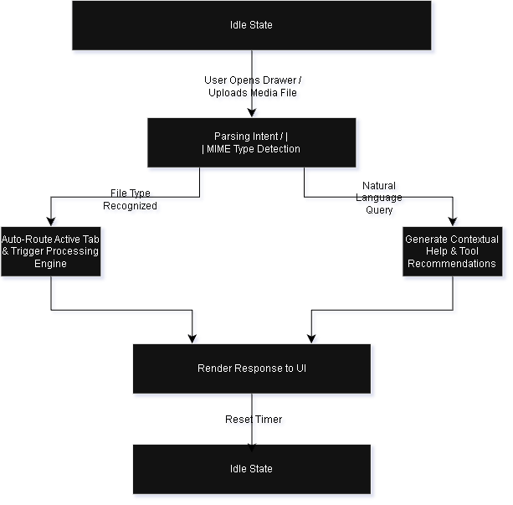

Appendix C: Interface Examples

EXAMPLE 1: AI Media Lab & Optical Code Suite Layout
Below is the user interface component mapping for the AI Media Lab and QR & Barcode Suite workstations:
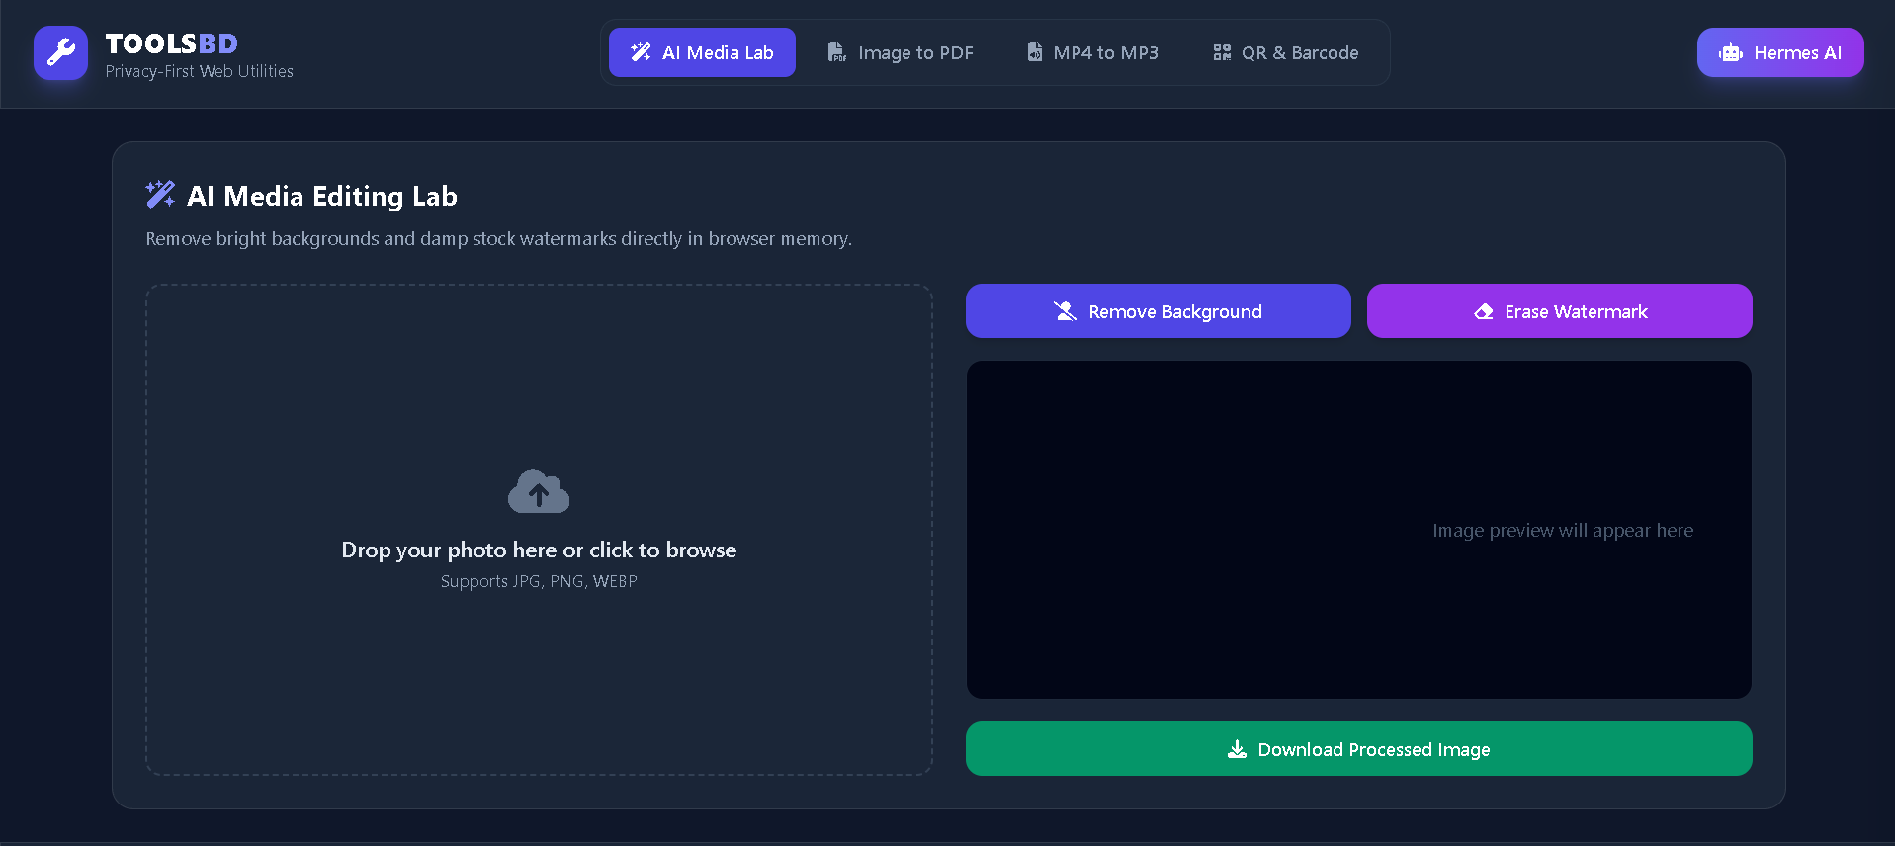

Interface Element Field Mapping
Item No. | Field / Control Name | Description
1 | System Logo & Title | Displays application branding (TOOLSBD) and client-side status indicator.
2 | Primary Navigation Bar | Tab selector buttons switching active views without page reloads.
3 | File Drag Dropzone | Interactive file selection boundary accepting JPG, PNG, WEBP, and MP4 files.
4 | Control Trigger Panel | Action buttons invoking local WebAssembly/Canvas pixel transformations.
5 | Working Canvas Viewport | Live HTML5 Canvas rendering area displaying real-time image edits.
6 | Download Action Button | Generates a volatile browser blob: link to trigger a local file download.

EXAMPLE 2: Optical Code Workstation Parameter Table
Field Name | Type / Constraints | Description & System Action
QR Input String | Editable Text Field (Max 2,048 chars) | Live input field. Triggers QRCode.toCanvas() on every keypress.
QR Output Canvas | Read-Only HTML5 Canvas Element | Displays rendered QR code vector matrix.
Barcode Input Payload | Editable Text Field (Max 80 chars, Alphanumeric) | Input for generating CODE128/EAN-13 barcodes.
Barcode SVG Output | Read-Only DOM SVG Container | Renders 1D industrial barcode vector graphics via JsBarcode.
QR Upload Reader | File Input Element (Images only) | Uploads QR code photo; decodes string payload using jsQR.
Decoded Text Output | Read-Only Text Container | Displays extracted text/URL decoded from scanned QR codes.

Appendix D: To Be Determined List
This section lists open items and future enhancements reserved for subsequent release versions (Version 2.0+):
Item No. | Topic / Requirement | Status & Proposed Resolution
TBD-1 | Client-Side Optical Character Recognition (OCR) | Evaluate integrating Tesseract.js WebAssembly build for offline text extraction from scanned images.
TBD-2 | Full PDF Page Reordering & Merging | Extend jsPDF integration to support reordering existing multi-page PDF documents locally.
TBD-3 | Offline Service Worker Caching (PWA) | Define Progressive Web App service worker caching strategies to allow 100% offline access when disconnected from the network.

